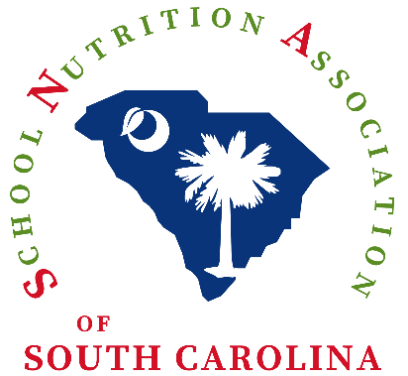

SNA Awards

The deadline for all awards is Friday, March 1, 2024, at 11:59 PM.

Please click on the first link for each category award to review the eligibility criteria to submit a nominee. The second link is to apply (submit a nomination).

Director of the Year Award:

- https://schoolnutrition.org/award/director-of-the-year-award/

- https://schoolnutrition.submittable.com/submit/264595/2023-24-sna-director-of-the-year

Manager of the Year in Honor of Louise Sublette:

- https://schoolnutrition.org/award/manager-of-the-year/

- https://schoolnutrition.submittable.com/submit/264596/2023-24-sna-manager-of-the-year

Employee of the Year Award:

- https://schoolnutrition.org/award/employee-of-the-year/

- https://schoolnutrition.submittable.com/submit/264597/2023-24-sna-employee-of-the-year

SNA of SC will recognize state winners in each category at the Annual State Conference in October with a plaque and $100.

If you have any questions, please contact Executive Director Joyce Lovett at snasc@bellsouth.net. She will share your questions or concerns with the Scholarship and Awards Committee.

