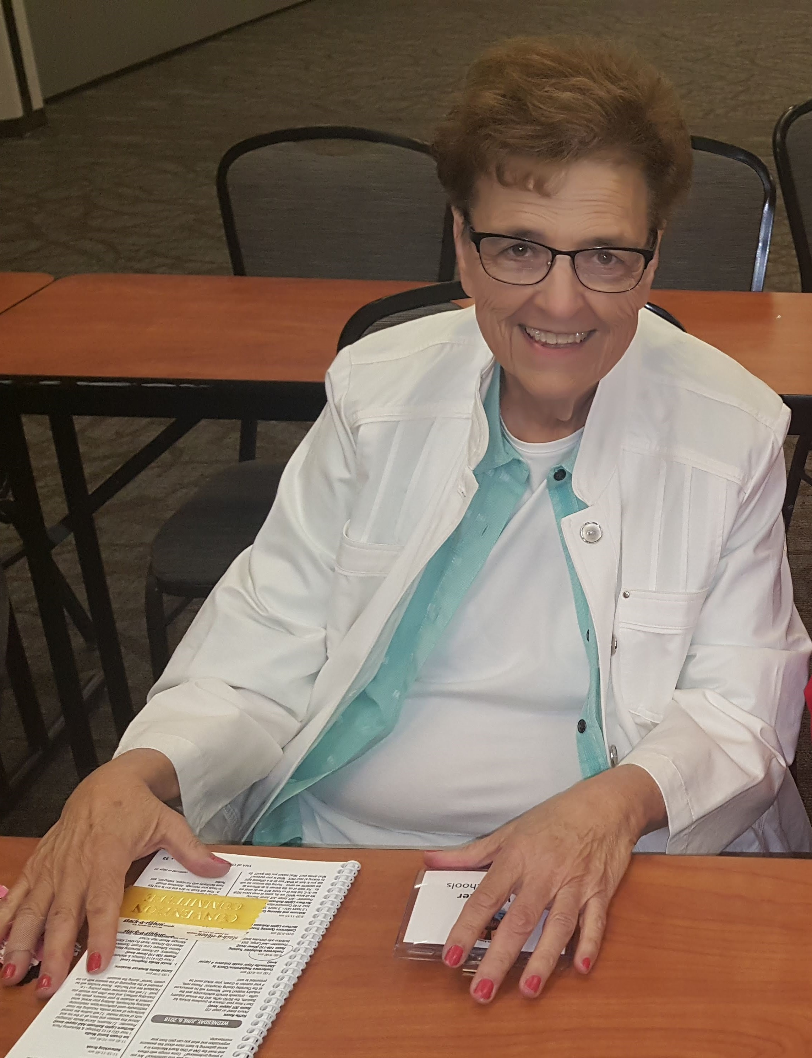
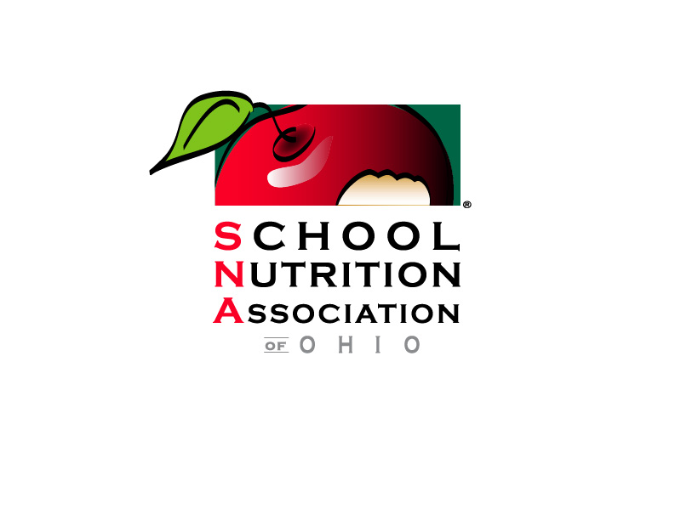

SUE WHITAKER
MEMBERSHIP AWARD PROGRAM

In July 2019, the SNA of Ohio lost - far too soon - longtime friend, supporter, and overall AMAZING person, Sue Whitaker. Sue was the Food Service Director of Huron City Schools. Sue gave 35 years of her heart and soul to a job that she found so rewarding.

Sue also gave her heart and soul to SNA of Ohio, SNA National, and her local SNA Chapter 22. Sue was involved with SNA for over 15 years, and she believed that with the right tools, anyone could make a difference in their district. She strongly believed that being an SNA member and attending educational events would help to provide these tools through professional development and networking.

The goal of the Sue Whitaker Membership Award Program is to honor Sue’s memory by helping to provide the tools she found so important in her school food service career. These tools are in the form of an SNA membership (a new membership for a non-member or a membership renewal for a current member) and financial assistance of up to $500 for the 2020 SNA of Ohio Annual Conference to be held June 16-18, 2020 in Columbus. All school food service employees are eligible to apply (members or non-members, and any category of school food service employee).

Submit this application form and essay via our online form at the
link below by March 1st. The recipient will be notified in early April.

http://snao.formstack.com/forms/sna_of_ohio_sue_whitaker_membership_award_2020

