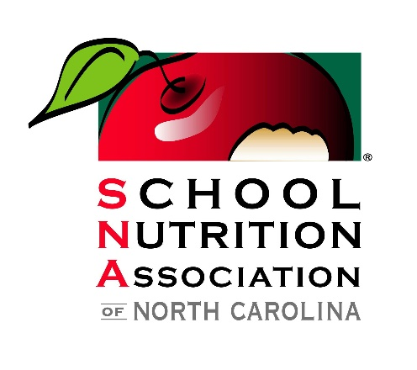

School Nutrition Association of North Carolina
2026 Industry Seminar
Agenda
January 26-28, 2026
Monday

12:00pm – 2:00pm Registration Open
11:00am – 2:00pm USDA Advisory Council Meeting
2:00pm – 4:00pm General Session
Farm 2 School (Walter Beal and NCDA)
5:00pm --6:00pm Reception with Cash Bar

Tuesday

8:00am – 8:30am Registration Open
8:00am – 8:30am Break
8:30am – 10:00am Welcome & Opening General Session
Kim Hodous, The Happiness Speaker
Be HAPPY. Lead HAPPY. Why Leaders Get Results, Not Resistance
10:15am – 10:30am Beverage Break
10:30am – 12:30pm (6) Innovation Stations
12:45pm – 1:30pm Networking Lunch
1:45pm – 2:45pm General Session
Equipment Procurement (Becky Sharpe)
3:00pm – 5:00pm (6) Innovation Stations
5:30pm – 6:00pm Social Hour with Cash Bar
6:00pm – 8:00pm Dinner

Wednesday

8:00am – 8:30am Break
9:00am – 11:30am Table-Top Show
11:45am – 12:45pm Closing Session
Smart Nutrition: AI in School Nutrition (Brian Lantz)

