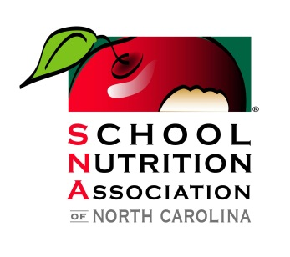
Educate, empower, and advocate for the school nutrition professionals to advance the integrity, the accessibility, and quality of school nutrition programs.
School Nutrition Association of NC Legislative Agenda 2026

The School Nutrition Association of North Carolina is comprised of 12,000 school nutrition workers in all 100 counties who dedicate themselves to nourishing the bodies and minds of school children throughout North Carolina.

We are very grateful, on behalf of the students we serve every day, for the NC General Assembly’s amazing support in recent years, especially in 2024 for appropriating $16 million for School Nutrition employees’ wages during post-Helene hurricane relief efforts in our mountain districts! (SL 2024-51, s. 6.1(a)(2)).
We cannot do this work without State support.

Thank you also for the state appropriations in 2023 that funded:
- $3 Million in recurring funds to permanently cover the student co-pay for reduced-priced meals; and
- $6.3 Million (recurring) to initiate the Community Eligibility Provision (CEP) pilot program at NCDPI that aims to “increase the number of students with access to healthy, cost-free school breakfast and lunch.” 269 additional schools have elected CEP for the school year 2024-25 and 157 of those schools qualified for this funding.

Our School Nutrition workers, and the children we serve, cannot survive and thrive without your critical State support. Our three (3) requests of the NC General Assembly for 2026 are as follows:

Request 1: Fund the differential on the state-mandated $15/hour pay increase enacted in 2021 for our non-certified School Nutrition personnel.
Many erroneously believe that the state appropriated funds for our non-certified workers’ wage increases, but that is not the case. Please show your support for School Nutrition programs in North Carolina during this legislative session by correcting this unfunded mandate.

This is mission critical for a host of reasons:
- The increased salary costs, combined with higher food costs and workforce challenges, continue to erode the ability for School Nutrition Programs to remain financially solvent. For example, approximately 84% of NC’s School Nutrition Programs (SNPs) were in the red post-pandemic. We must have State funding now unlike ever before to support our programs and children.
- Meal prices for students would need to be increased unrealistically to offset the increase in salary costs resulting from the mandated pay increase. A radical increase in school meal prices will result in fewer students participating in our programs, further exacerbating not only our program’s financial stability, but also the child hunger problem in North Carolina.

Request 2: Support the School Meals for All initiative in North Carolina. 81% of registered voters support providing school meals at no cost. Offering universal school meals at no cost supports school attendance, increased test scores and improved student health, both physical and mental. It would also drastically reduce the administrative burden on school districts’ school nutrition departments, allowing greater focus and resources to be applied towards menus and service.

Request 3: Please contact your Congressional delegation and ask them to maintain or increase federal funding for School Meals – funding that our children and NC farmers depend on every day! School Nutrition programs support our NC and domestic farmers and growers: please help us keep it this way.

The future of North Carolina School Nutrition Programs is in your hands. School Nutrition programs provide the best value in supplemental feeding programs, guaranteeing the funds go directly to providing nutritious and wholesome meals to students. Your support is greatly appreciated. For great information on how School Nutrition programs are funded in NC, please see https://www.ednc.org/school-meals-finance/
April 14, 2026

