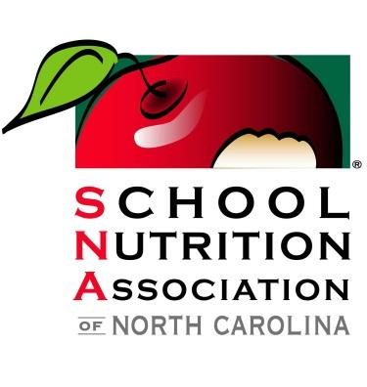

Educate, empower, and advocate for the school nutrition professionals to advance the integrity, the accessibility, and quality of school nutrition programs

Dear Sustaining Member,

Our Annual Conference in Greensboro is coming up, June 21-22, 2023. As you know, this is an exciting and educational event for our members. Each year, many of our industry friends ask how they can help us with this event. We have a list of ways that you and your company can help us provide an exceptional experience for School Nutrition employees. At the same time, we can provide recognition for your company.

We have divided the sponsorships into different levels. The amount of company exposure and recognition increases with each level. We invite you to look over this list and return the enclosed form to us as soon as possible. If you decide to be a sponsor, we need your contribution by May 15, 2023, in order to print your company name in the program and on the signs. If you have any questions about the sponsorships, please contact Dawn Ferguson Roth at jbdfroth@aol.com or 888.204.8204.

SPONSOR LEVELS

PLATINUM LEVEL $3000 +  Company Name in Arrow  Company Name in Program  Company Name on Signage  2 Banquet Tickets (Thurs. Night)  Sponsor Ribbon on Badge | GOLD LEVEL $1500 +  Company Name in Arrow  Company Name in Program  Company Name on Signage  Sponsor Ribbon on Badge | SILVER LEVEL $500 +  Company Name in Program  Company Name on Signage  Sponsor Ribbon on Badge

Thank you for your support of the School Nutrition Association of North Carolina. We hope to hear from you soon.

Very truly yours,

Janet Johnson & Stephanie Hall
Conference Co-Chairs

2318 North Elm Street • Greensboro, North Carolina 27408

School Nutrition Association of North Carolina

Koury Convention Center

Sponsor Information
The options listed below are opportunities to sponsor speakers, presenters, entertainment or other parts of our conference. Please indicate your choice of level.

Platinum $3000 + Total Platinum Level Amount ____________

Gold Level $1500 + Total Gold Level Amount ____________
Silver Level $500 +______________Total Silver Level Amount ____________

Sponsor and Payment Form

Sponsor form and payment must be received by May 15, 2023, in order for your company to be recognized in the program and with signs.
Payment Information
Check or Credit Card Accepted

Mail Form with Check or Credit Card Information to:
SNA-NC
2318 N. Elm St.
Greensboro, NC 27408
jbdfroth@aol.com

Amount enclosed: ______________

Visa__ MasterCard__ AMEX___
________________________________
Credit Card Number

________________________________
Exp. Date

_______________________________
Signature
________________________________
3 or 4 Digit Security Code

_________________________________

_________________________________ Billing Address for Credit Card Statement

____________________________________
Email Address for Receipt

___________________________________________
Company Name to Appear in Signage

___________________________________________
Name of Contact Person

___________________________________________
Mailing Address

___________________________________________
City/State/Zip

___________________________________________
Amount Enclosed

___________________ _____________________
Phone Number Cell

___________________________________________
E-mail Address

___________________________________________
Signature Date

