SNA-NC Plan of Work
2022 - 2023

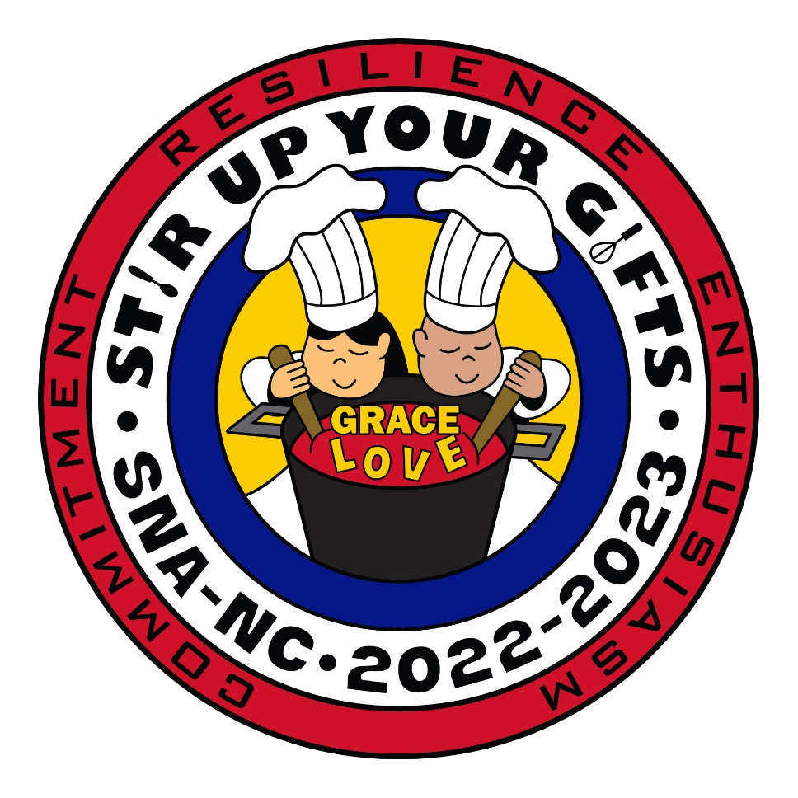

Goal 1: Voice of the School Nutrition Industry

Objective:

- Acknowledge and recognize school nutrition experts
2- Enhance the professional, diverse image of school nutrition
3- Advocate for nourishing the mind, body, and soul of our country’s future

Strategies:
- Provide ideas, resources, and training for school nutrition members to enhance programs, increase efficiency, and support career development.
- Educate our members on the importance of proper nutrition and the value of educating our students about nutrition.
- Share clear and consistent message of advocacy with our stakeholders regarding our student’s nutrition for a strong future.
- Provide guidance and training to nominate individuals for awards and recognition.

Action | When | Committee | Budget | Review | Status
Keep members and legislators updated on current issues | Ongoing | PP&L
Make awards/scholarships information available monthly to more members via email, social media & website informing them to apply for scholarships year-round. | Ongoing | Leadership & Development
Celebration themes for website and social media “Across County Lines” efforts. Market awards and scholarship guidelines for awards. | Ongoing | Marketing
Promote new and innovative products, services, and concepts while networking with individual partners at the annual trade show. | Summer 2023 | Industry
Promote nutrition education with self-wellness to members. | Fall & Spring Arrow 2022-2023 | Nutrition
Goal 2: Career Development and Growth

Objective:
- Increase the opportunities for professional growth of members and build their capacity to lead in their schools and districts.
- Serve as a hub for members to network and build lifelong relationships around common goals and interests.
- Educate members in diversity, equity, inclusion, and access.

Strategies:
- Enhance the quality of professional development offered in a variety of formats for all members.
- Create goals to grow school nutrition professionals through mentorship.
- Promote pathways that are engaging with new and relevant opportunities for all members.

Action | When | Committee | Budget | Review | Status
Annual PP&L education session at SNA-NC conference | June 2023 | PP&L
Enhance SNA-NC website page to list local chapter activities and ideas to increase professional development at local chapter meetings. | Fall 2023 | Membership
Promote new recipes & educate on nutrition requirements. Each district will share a recipe. | Fall & Spring Arrow | Nutrition
Continue sharing UNCG kitchen skills, safety and sanitation videos on the SNA-NC and YouTube website. | Spring 2023 | Endowment
Consider changing “Chapter Leadership” session to “Leadership,” to be more inclusive of members. Still have “Chapter Leadership” and include the additional leadership course to enhance the pre-con session content. | 2022-2023 | Leadership & Development
Provide SNA officer duty descriptions in the Arrow. | Fall & Spring 2022-2023 | District Directors
Have a Breakout session at SNA-NC Conference. | Annual Conference 2023 | District Directors
Promote Diversity, Equity, and Inclusion sessions at SNA-NC Conference. | SNA-NC Annual Conference 2023 | Marketing

Goal 3: A vibrant community of School Nutrition Stakeholders

Objective:

- Elevate the relationship and partnerships with school nutrition industry.
- Develop relationships with internal stakeholders, such as superintendents, local board of education, principals, teacher, etc.
- Develop relationships with external stakeholders such as legislators, community outreach organizations, parents, etc.

Strategies:
- Continue to create new partnerships with allied organizations to maximize influence on topics of mutual interest and benefits.
- Strengthen our existing relationships both within and outside our current sphere of influence.
- Share strategies, research, and solutions to drive positive change and innovation to the school nutrition industry.
- Invite and include contributions from school nutrition members equally while encouraging mutual respect and collaboration.

Action | When | Committee | Budget | Review | Status
Collaborate with other allied associations | Ongoing | PP&L
Provide materials to directors to share w/local stake holders. | Ongoing | PP&L
Create a membership video for the webpage with other members answering the question” why are you an SNA member, etc. | Summer/Fall  2022 | Membership
Promote “National take your parents/guardians to lunch Day” & “NSLW” & “NSBW” | Fall & March 2023 | Nutrition
Have a membership drive and advocacy drive that will involve partners and stakeholders. | Fall/ Spring 2022-2023 | Marketing
Provide template for director presentation at school board meetings. | Fall/Spring 2022-2023 | Marketing
District Directors will invite community stakeholders to district meetings (Superintendents, Finance Officers, County Commissioners, etc.) | Ongoing | District Directors
Encourage Industry Partners to become more involved with SNA by becoming sustaining members. | Ongoing | Industry
Collaborate with UNCG to provide training and scholarships to prepare for career development. | June 2023 | Endowment
“Culinary Medicine” education mini session, “Art of Food and Cooking with the Science of Medicine” provided by intern stakeholders at UNCG. | June 2023 | Endowment

Goal 4: School Nutrition is a thriving organization.

Objective:
- Create a strong pathway to volunteer leadership and provide inclusive opportunities for contribution.
- Find ways to enhance our business models to lead the way to innovation and new revenue opportunities.

Strategies:
- Bring forth aspiring association leaders who are qualified, motivated, and representative of the membership.
- Increase in the diversity and number of members who contribute their time and talent to our organization.
- Create diverse revenue streams which contribute to the financial health of the association.
- Increase our membership with innovative programs.

Action | When | Committee | Budget | Review | Status
Create survey to find out what can SNA do for me? What can I contribute to SNA? What are my strengths? | SNA-NC Conference 2022-2023 | Membership
Encourage Industry Partners to become more involved with SNA by becoming sustaining members. | Ongoing | Industry
Recruiting the next great leaders for our association | Fall 2022 | Leadership & Development
Provide SNA officer duty descriptions in the Arrow. | Ongoing 2022-23 | District Directors
Have a Breakout session at SNA-NC Conference. | SNA-NC Annual Conference 2023 | District Directors

